## Front End Engineering-II

Project Report

Semester-IV (Batch-2022)

Agency – Based Website

(Template 21)

**Supervised By: Submitted By:**

Raveesh Samkaria Vansh Sharma

2210990939

G-14

**Department of Computer Science and Engineering**

## Chitkara University Institute of Engineering & Technology,

## Chitkara University, Punjab

**ABSTRACT**

This abstract delineates a blueprint for an Agency-Based website, exclusively developed using CSS and HTML, with a primary focus on responsive design catering to both desktop and mobile environments. The template is intricately designed to provide users with a seamless experience, incorporating elements such as intuitive navigation, visually appealing layouts, and interactive components.

Key components of the template include a dynamic menu interface, enhancing user accessibility and facilitating effortless exploration across various site options. The streamlined order placement process is characterized by clear call-to-action buttons, ensuring a straightforward and efficient user journey. The design aesthetic remains consistent and visually engaging, delivering a cohesive experience on both desktop and mobile platforms.

A notable feature of the template lies in its implementation of CSS media queries, enabling optimal presentation. This adaptability ensures a fluid transition between the distinctive requirements of desktop and mobile environments, enhancing the overall user experience.

With its versatile foundation, the template is well-suited for the development of a sophisticated food delivery website. It successfully strikes a balance between aesthetic appeal and a user-centric approach in both desktop and mobile contexts. The cohesive integration of HTML and CSS technologies establishes a robust framework for creating an impactful and responsive online presence, aligning with contemporary standards in web design.

**1. Introduction**

In the ever-evolving landscape of web development, this introduction unveils the conception and development of a groundbreaking Agency-Based website template. Crafted exclusively with the robust tandem of CSS and HTML, this template emerges as a versatile and responsive solution, meticulously designed to transcend the boundaries of traditional desktop-centric designs and embrace the dynamic demands of contemporary mobile users.

**1.1 Background:**

Against the backdrop of a digital era characterized by rapidly advancing technologies and changing user expectations, the imperative to craft websites that are not only visually engaging but also adapt seamlessly to various devices has become paramount. Recognizing this paradigm shift, our dedicated team undertook the challenge of conceptualizing and implementing an Agency-Based website template. Grounded in the simplicity and versatility of CSS and HTML, the template aims to redefine the standards of online agency representation.

**1.2 Objectives:**

The overarching objective of this project is to engineer a template that not only reflects the latest trends in web design but also places user experience at the forefront. Leveraging the power of CSS media queries, our goal is to achieve optimal responsiveness, ensuring that the template provides a consistent and immersive user experience across the diverse spectrum of desktop and mobile screens. With an emphasis on adaptability, the project aspires to offer agencies a comprehensive foundation to establish an influential and dynamic online presence.

**1.3 Significance:**

The significance of this template transcends mere aesthetics, delving into the realms of enhanced functionality and user-centricity. Through the seamless integration of CSS and HTML, we endeavour to deliver a template that captivates visitors not only through its visual appeal but also through an intuitive and efficient user journey. The incorporation of a dynamic menu interface, strategically placed call-to-action buttons, and a design aesthetic that remains visually cohesive across different platforms underscore the template's importance in redefining how agencies engage with their audiences online.

In essence, this introduction serves as a prelude to a comprehensive exploration of a web development initiative that seeks to go beyond the ordinary. By harnessing the capabilities of CSS and HTML, our Agency-Based website template represents a convergence of design and technology, promising an online experience that seamlessly adapts to the diverse needs of the modern digital landscape.

**Problem Definition:**

In order to embark on the journey of creating a revolutionary Agency-Based website template, a comprehensive understanding of the challenges and requirements is imperative. This section delves into the nuanced aspects that guided the development process, laying the foundation for a solution that addresses specific problems while meeting a set of defined criteria.

In the contemporary digital landscape, agencies face a myriad of challenges in establishing an impactful online presence. Conventional website templates often fall short in catering to the dynamic needs of users across desktop and mobile platforms. The primary problem identified is the lack of a versatile solution that seamlessly adapts to various screen sizes while maintaining a visually engaging and user-friendly interface. This gap hampers agencies in delivering a cohesive brand experience to their audience.

**Requirements:**

Addressing the identified problems necessitates a set of well-defined requirements that guide the development of the Agency-Based website template. These requirements serve as a roadmap, outlining the key functionalities and characteristics that the solution must embody:

1. Responsive Design: The template must be responsive, dynamically adjusting its layout and content to provide an optimal viewing experience on devices of varying screen sizes.
2. Intuitive Navigation: User-friendly navigation is crucial. The template should incorporate an intuitive menu structure that allows users to seamlessly explore different sections of the website.
3. Consistent Aesthetics: A visually consistent design aesthetic is essential to ensure a cohesive brand identity. The template should maintain visual harmony across desktop and mobile platforms.
4. Dynamic Menu Interface: An interactive and dynamic menu interface is required to enhance user engagement, enabling swift and effortless navigation throughout the website.
5. Clear Call-to-Action: Strategic placement of clear call-to-action buttons is necessary to guide users through the desired actions, such as placing orders or exploring specific services.
6. Efficient Order Placement Process: Streamlining the order placement process is critical. The template must facilitate a straightforward journey from product selection to order completion.
7. Optimized Performance: Performance optimization is paramount. The template should prioritize fast loading times and efficient resource utilization to enhance the overall user experience.

By elucidating the problems faced by agencies in the digital realm and establishing clear requirements, this section sets the stage for the subsequent design and development phases. The envisioned Agency-Based website template aims not only to address these challenges but also to surpass expectations, providing a comprehensive solution that aligns with the evolving needs of the online landscape.

**Proposed Design and Methodology:**

In the pursuit of revolutionizing the Agency-Based website template, our proposed design and methodology embrace an innovative approach that seamlessly integrates visual appeal with functional efficiency. This section outlines the envisioned design principles and the systematic methodology that guides the development process.

**1.2 Design Concept:**

The design concept revolves around creating a visually stunning yet highly functional template that caters to the dynamic needs of agencies and their diverse audiences. The aesthetic foundation is rooted in simplicity, ensuring a clean and modern interface that aligns with contemporary design trends. Visual cohesiveness remains a focal point, with a consistent colour palette, typography, and imagery contributing to a unified and engaging brand identity.

Strategic placement of clear call-to-action elements guides users through the desired actions, creating a purposeful and efficient user journey. The order placement process is streamlined, offering a straightforward pathway for users to explore services or make purchases. This emphasis on efficiency aligns with our goal of providing a template that not only captivates visually but also facilitates user interactions with ease.

**1.2 Methodology:**

Our development methodology adheres to a systematic and iterative approach, ensuring each stage contributes meaningfully to the realization of the proposed design. The methodology encompasses the following key phases:

1. Research and Analysis: In-depth research and analysis lay the foundation for understanding user preferences, industry trends, and technological advancements. This phase informs design decisions and ensures alignment with the evolving needs of agencies.
2. Conceptualization and Wireframing: The conceptualization phase translates research findings into a tangible design concept. Wireframing is employed to outline the structural framework, ensuring a cohesive and user-friendly layout.
3. Design Prototyping: Design prototyping brings the wireframes to life, allowing for a visual representation of the proposed template. Prototypes undergo iterative refinement, incorporating feedback and fine-tuning visual elements.
4. Development and Coding: The development phase involves translating the finalized design into functional code using HTML and CSS. Responsive design principles and best practices guide the coding process, ensuring compatibility across devices.
5. Testing and Optimization: Rigorous testing is conducted to identify and rectify any issues related to functionality, responsiveness, and performance. Optimization efforts focus on enhancing user experience and addressing potential bottlenecks.
6. Deployment and Evaluation: Upon successful testing, the template is deployed to a live environment. Continuous evaluation and user feedback contribute to ongoing improvements, ensuring the template remains adaptive to evolving requirements.

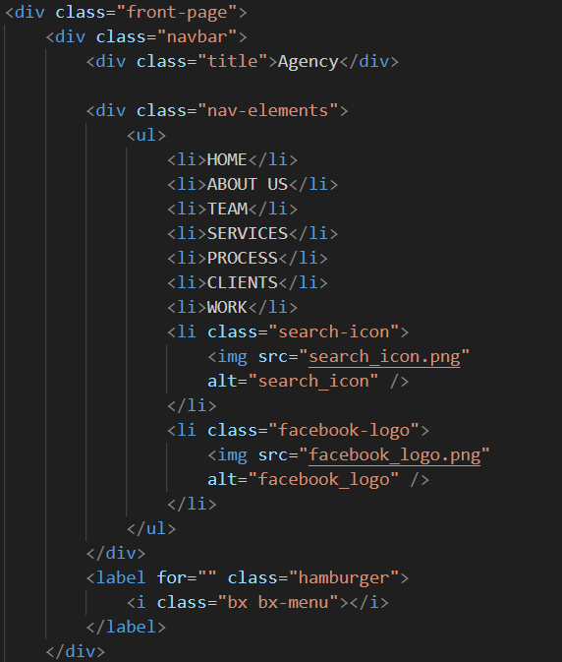 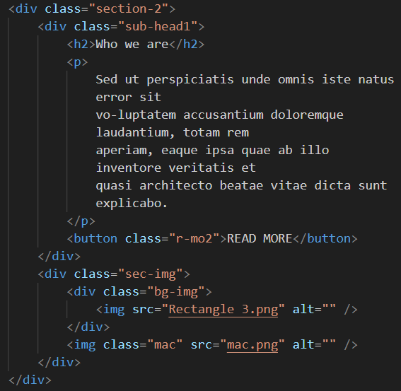

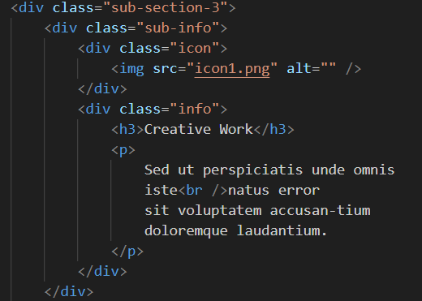 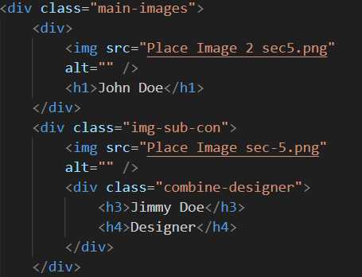

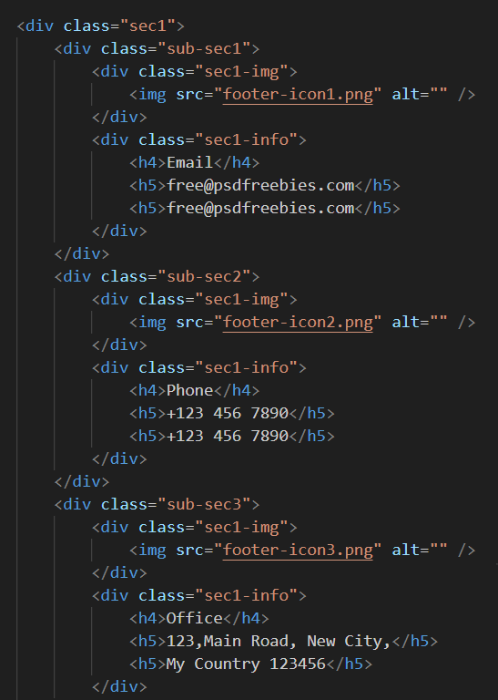

This proposed design and methodology encapsulate our commitment to creating a cutting-edge Agency-Based website template. By harmonizing aesthetic excellence with a methodical development approach, we aspire to deliver a template that not only meets but exceeds the expectations of agencies in the digital realm.

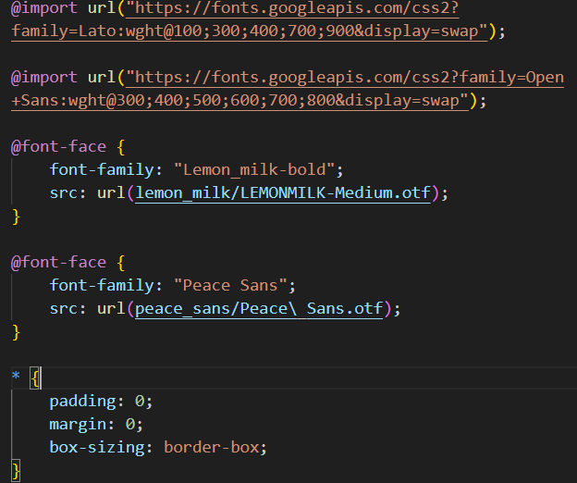 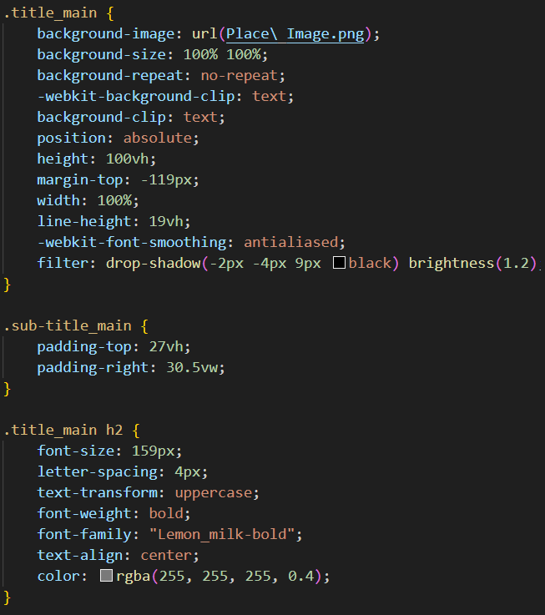

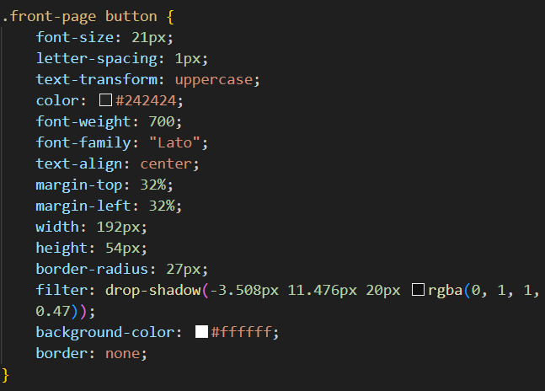

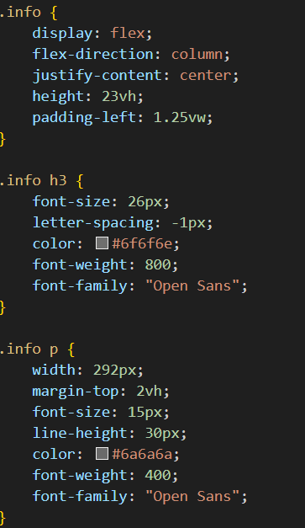 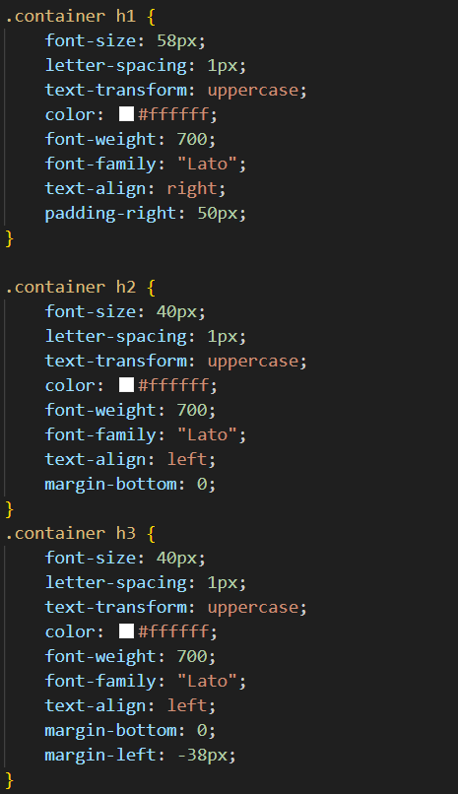 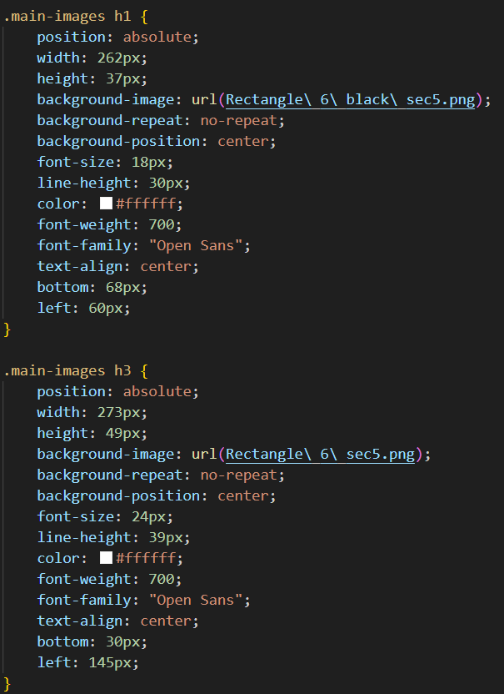

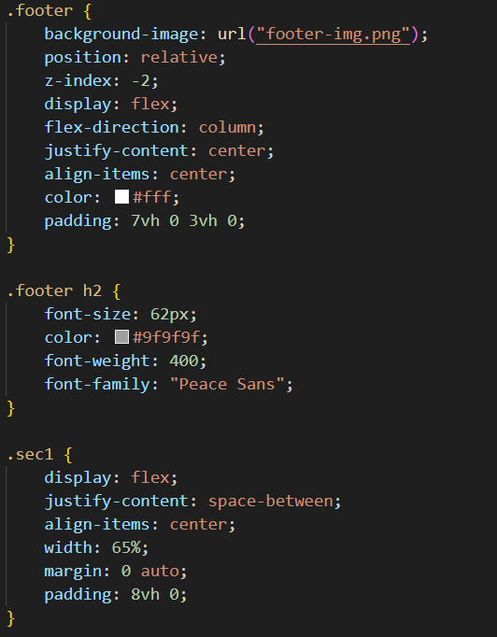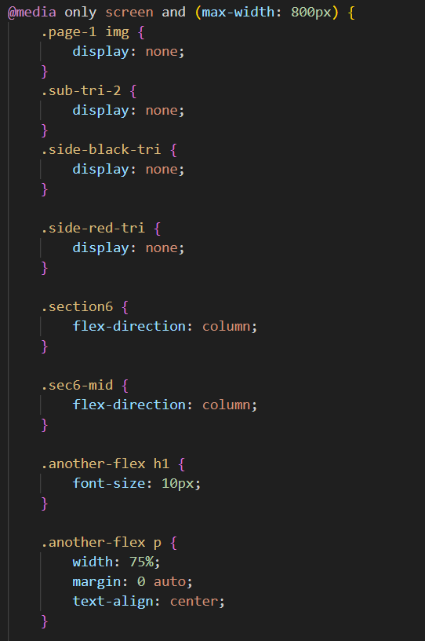

**Results:**

Snippets of the website attached below:

4.1 Desktop view:



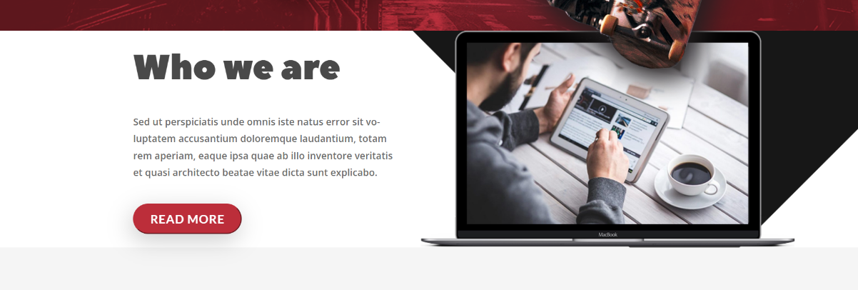

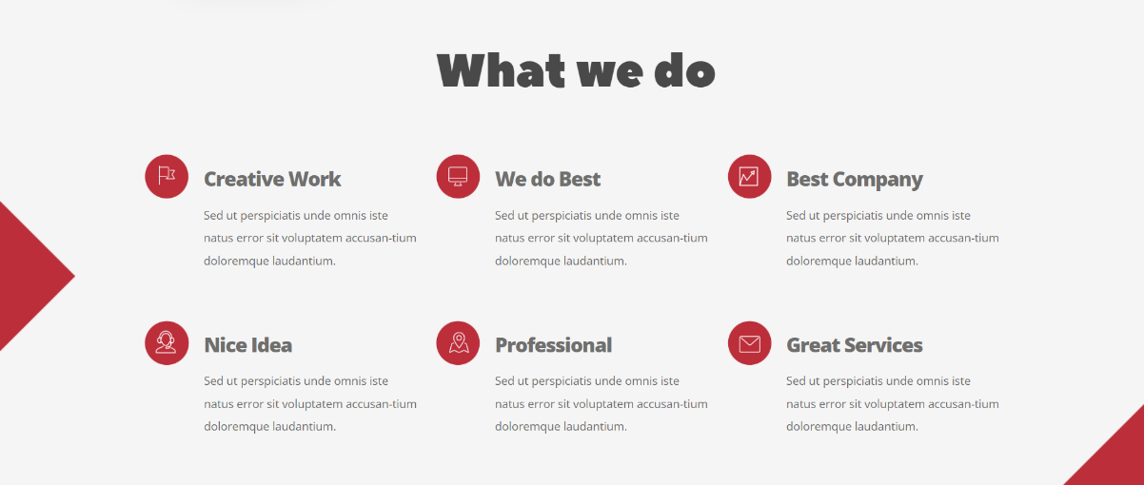

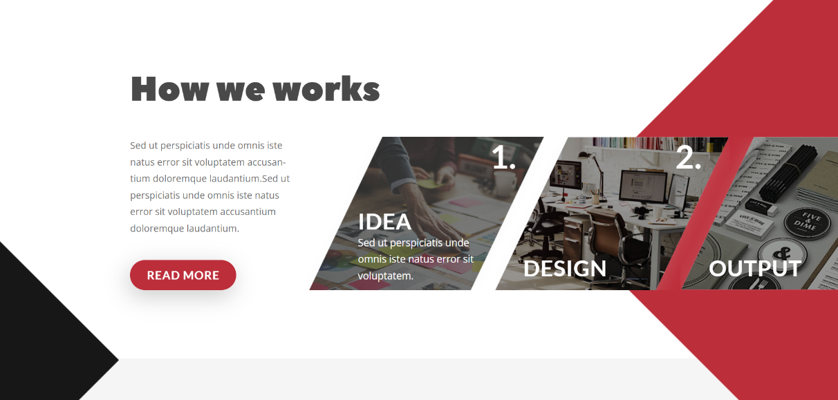

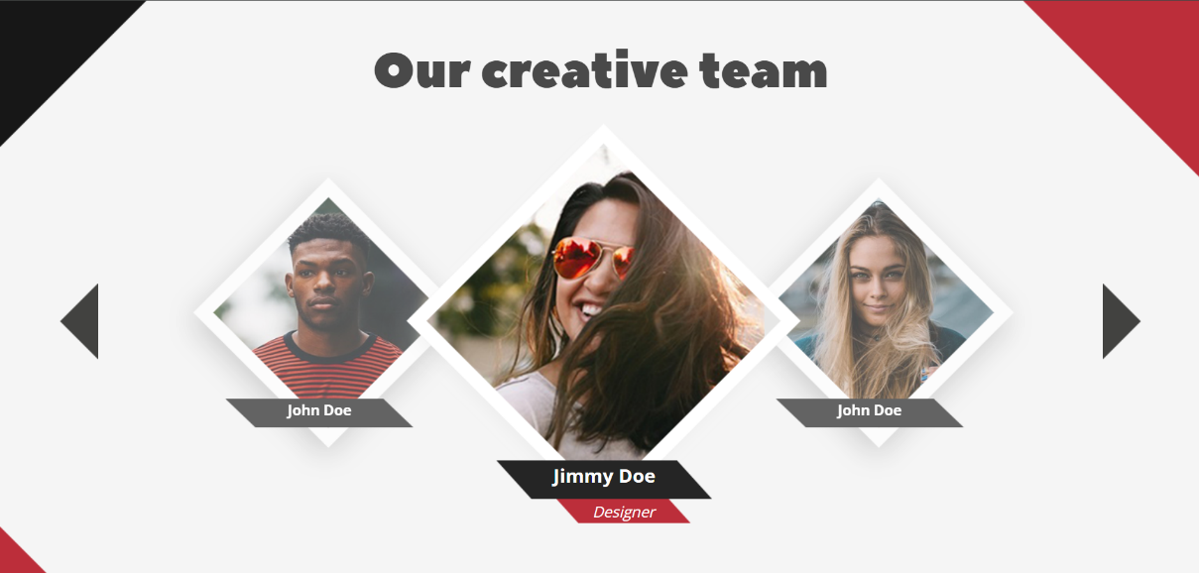

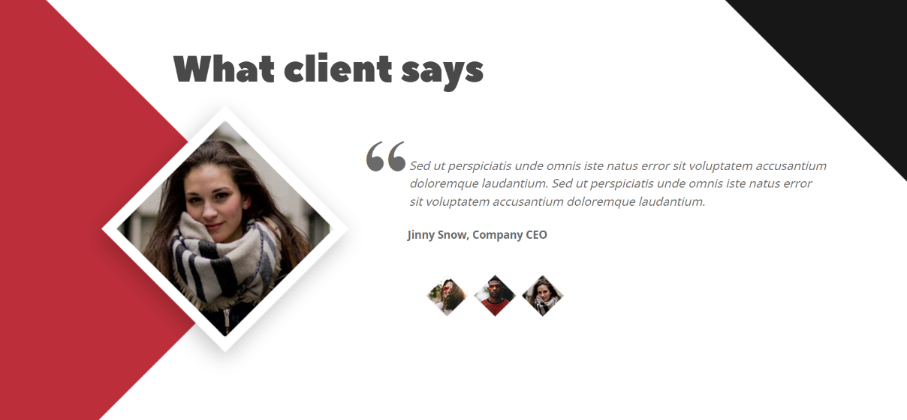



4.2 Mobile view (max-width 459px):

